SQL
(Structured Query Language)

What is SQL?
-SQL, or Structured Query Language, is a domain-specific, standardized programming language used to manage and manipulate data in relational database management systems (RDBMS). It is the language used to interact with databases that store data in structured tables, composed of rows and columns.

How to import data from Excel,Json and CSV file?

Importing a CSV File (using MySQL Workbench's Table Data Import Wizard)
Steps to importing data in SQL.
- 1.Open MySQL Workbench and Connect: Launch MySQL Workbench and connect to your desired MySQL server instance.

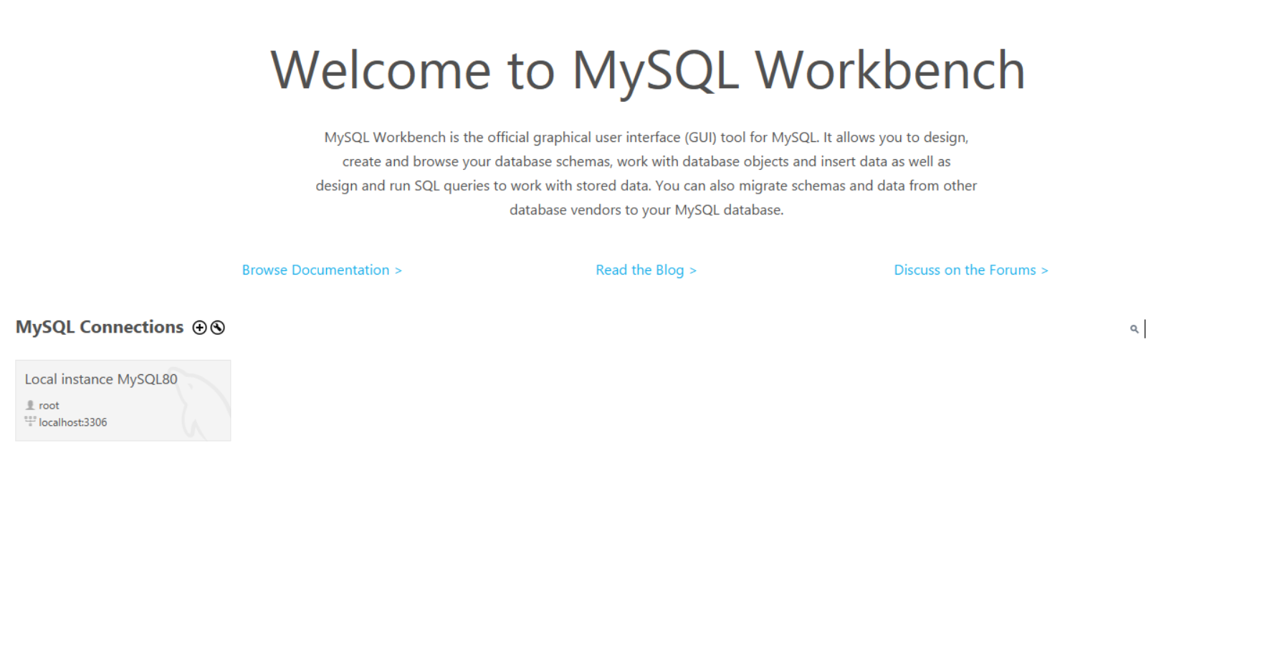

- 2.Create database for importing data.
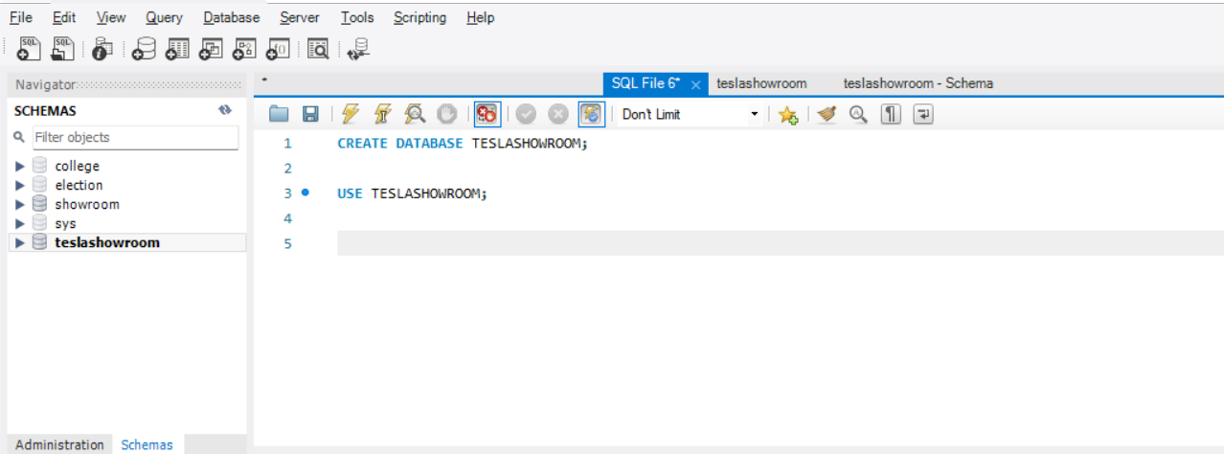

- Create database,execute the database and use it.
- After creating database you will see your database in schema.

- 3.Right-Click Database and Select Import Wizard: In the Navigator panel, right-click on the target database (schema) and select "Table Data Import Wizard."
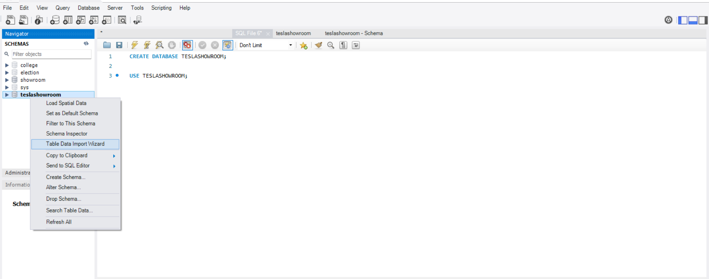

- 4.Select CSV File: Browse and select your CSV file.

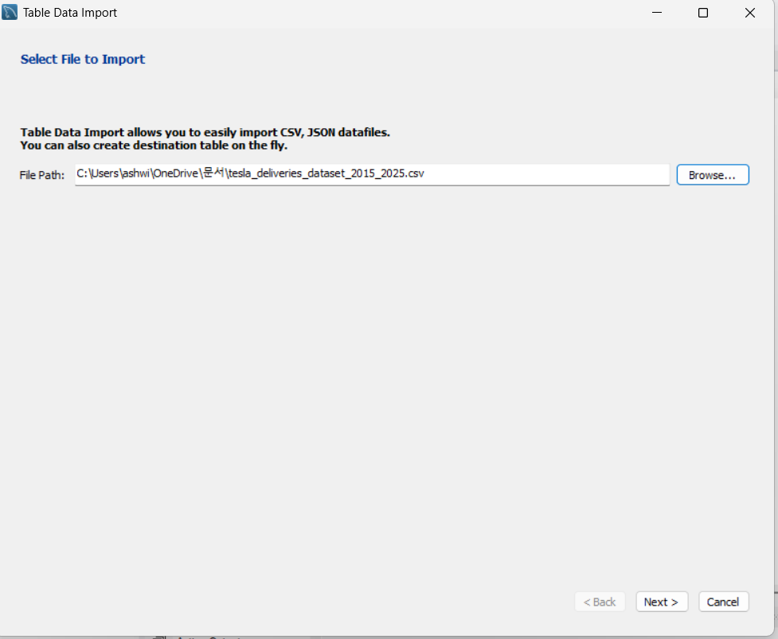

- 5.Choose Target Table: You can either import into an existing table or create a new one based on the CSV data.
- 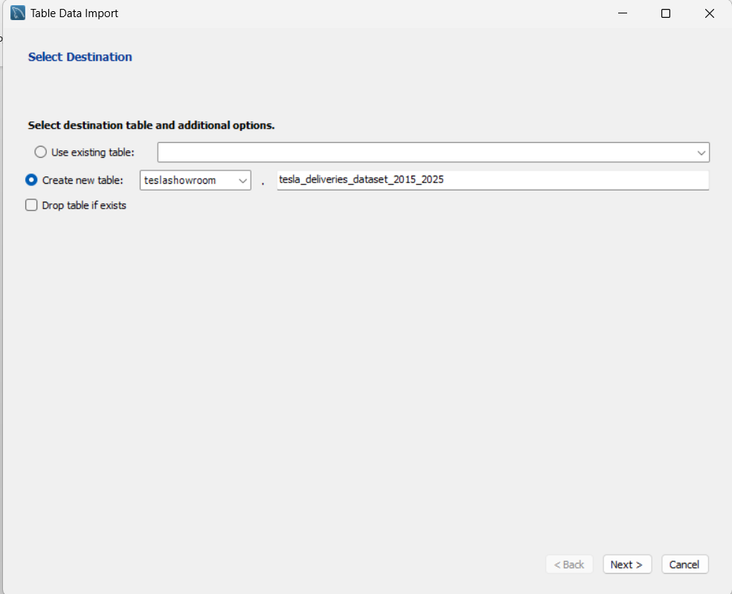

- 6.Configure Import Settings: Review and adjust column mappings, data types, and other settings as needed.
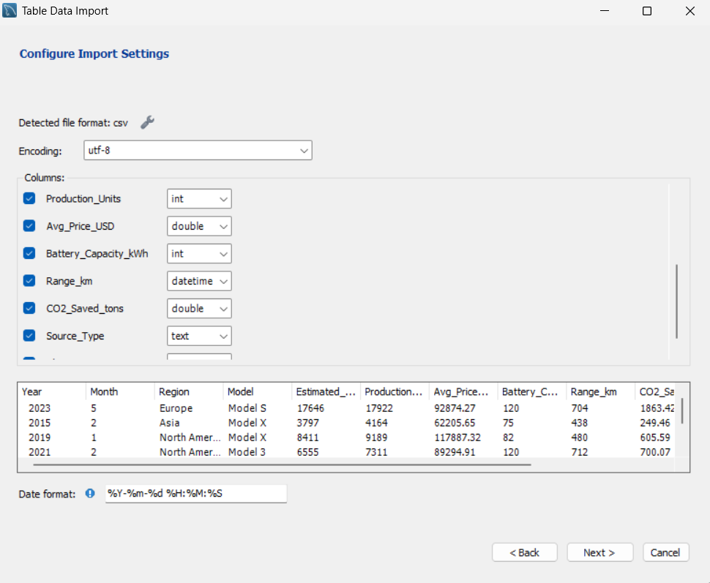

- 7.Start Import: Click "Next" and then "Start Import" to execute the import.
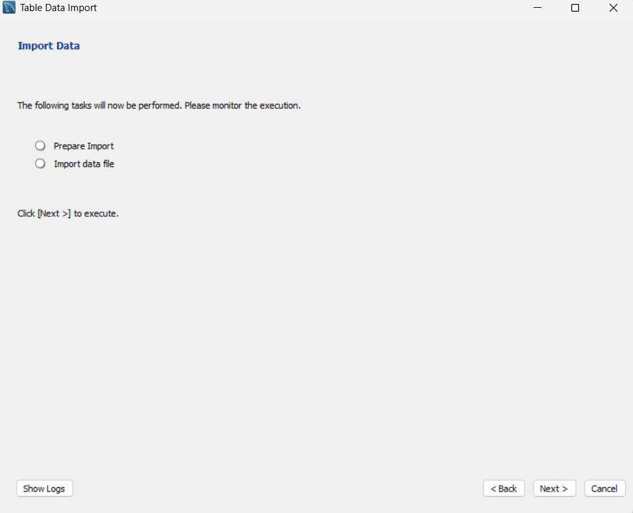

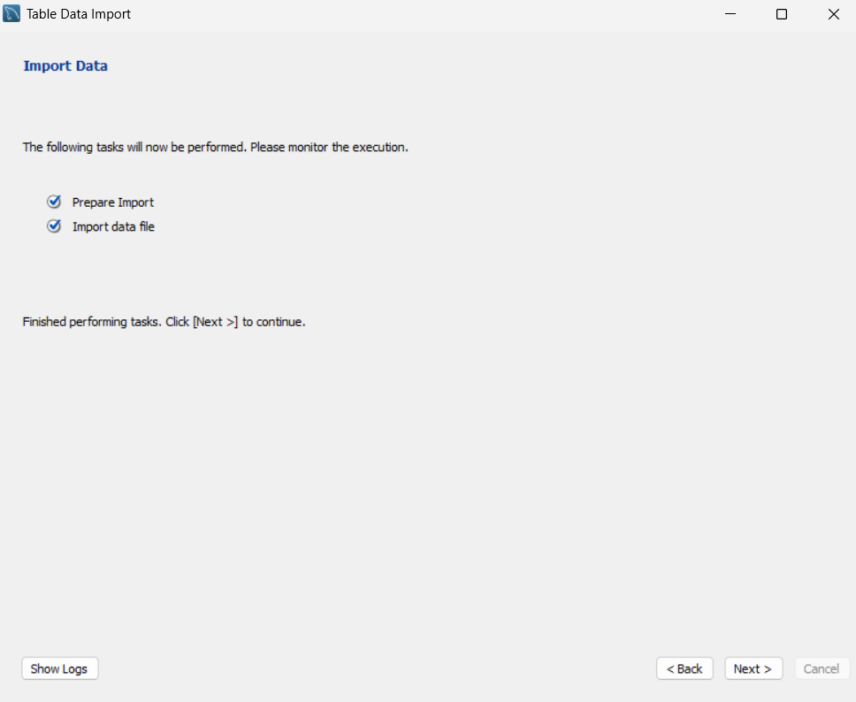

- After import you can see import results that which data imported,where imported and how much data imported.
- Click on finish.

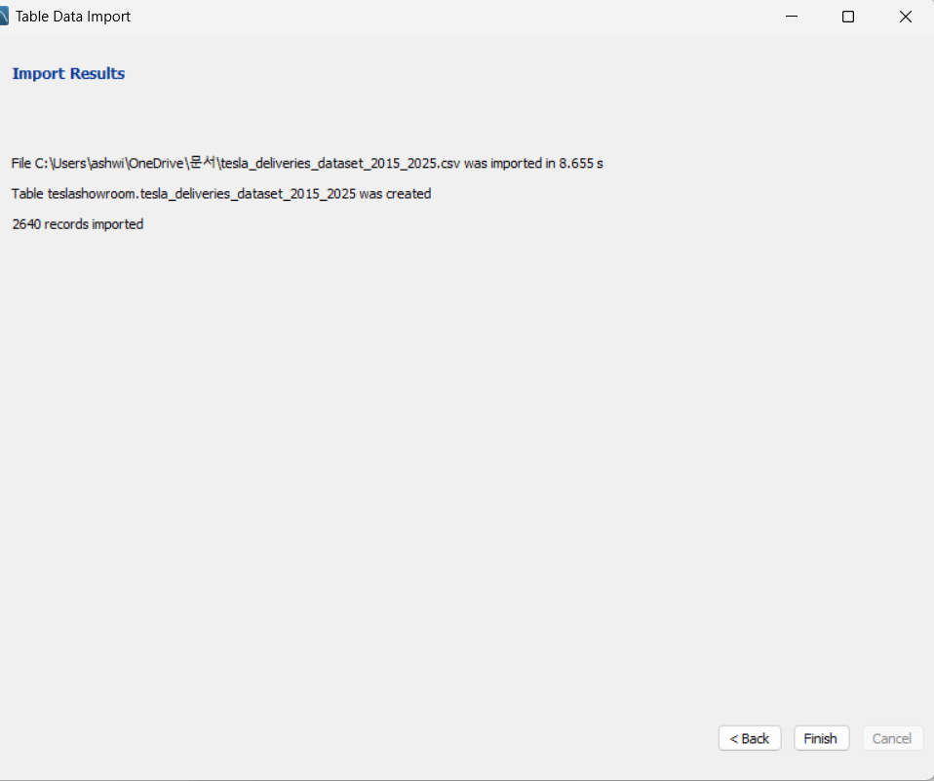

- 8.Verify: After completion, refresh the table and view its rows to confirm the imported data.
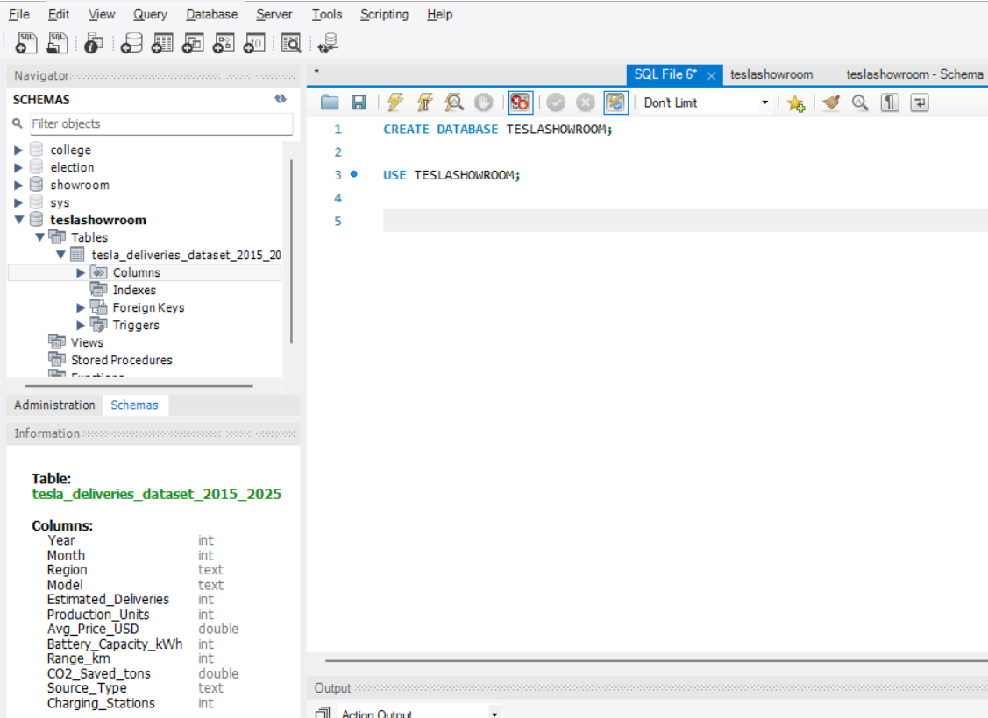

- Here you can see your created database,table,rows and columns.

After import data you can read,create,update,delete your records by writing SQL Queries.

- For reading your records in SQL write Query like this
SELECT * FROM ……your table name;
Example. SELECT * FROM TESLA_DELIVERIES_DATASET_2015_2025;

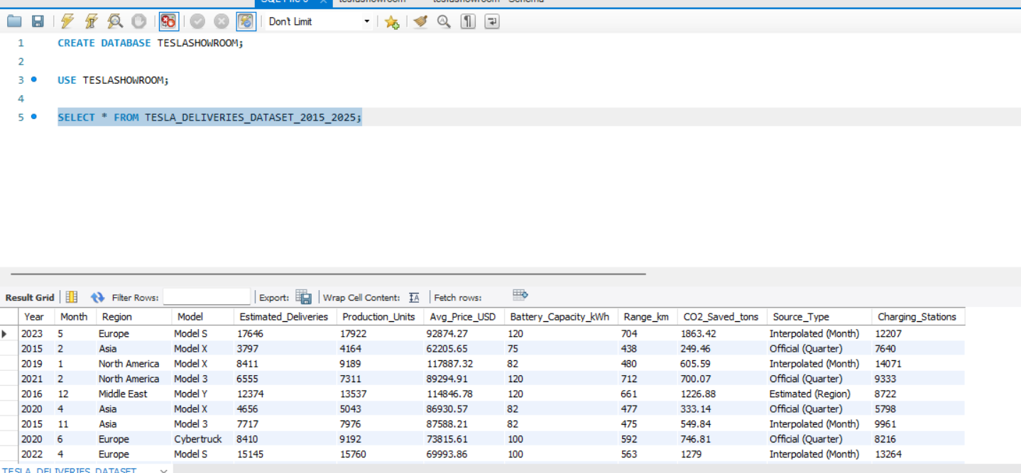

- Write your query and execute it.

- After executing query you can see your records in result grid.

- How to get dataset ?

https://www.kaggle.com/datasets.

- Just visit website.
- Select dataset which you want.
- Download it.
- And keep practicing.

